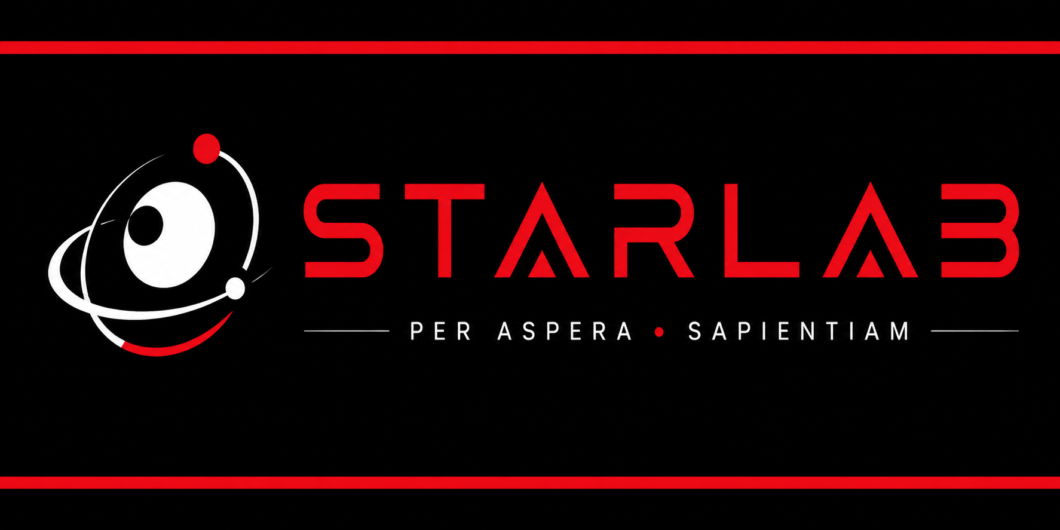
Student Onboarding Packet
Science Through Advanced Research, Learning, Application, and Building

Purpose of this packet
This packet helps students understand how STARLAB works, what they are responsible for, how research documentation is handled, how safety and approval work, and what to do when they get stuck.

Student Name: ____________________________________________ Period: ____________
Teacher: _________________________________________________ School Year: ________

Start Here: What Is STARLAB?
STARLAB is a research-based science course. Instead of every student completing the same lab with a known answer, you will develop, investigate, document, analyze, and present your own scientific or engineering project.
This course is designed to help you work more like a developing scientist, engineer, researcher, designer, or problem-solver. You will not always know the next answer immediately. That uncertainty is part of the course.
Core message
STARLAB is not about pretending your project went perfectly. It is about learning how to ask better questions, build stronger plans, collect trustworthy evidence, respond to problems, and communicate what your evidence honestly shows.

The STARLAB Year at a Glance
Unit | Timeline | Main Purpose
Unit 1 | Weeks 1-2 | Research foundations, experimental design, ethics, and early project ideas
Unit 2 | Weeks 3-4 | Project planning, hypothesis/design criteria, safety, ethics, and approval
Unit 3 | Weeks 5-16 | Pilot testing, research journals, troubleshooting, and data collection
Unit 4 | Weeks 17-20 | Data organization, analysis, graphs, uncertainty, and interpretation
Unit 5 | Weeks 21-28 | Scientific report writing, visual communication, and presentation preparation
Unit 6 | Weeks 29-34 | Final presentation, Q&A, reflection, portfolio, and next steps

How This Course Is Different
Traditional Science Class | STARLAB Research Course
Teacher often gives the procedure. | You help design, revise, and justify the procedure.
The expected result may already be known. | The result may be uncertain, messy, incomplete, or surprising.
Most students complete similar work. | Projects may look very different from one student to another.
A lab may be finished in one or two class periods. | Research develops across weeks and months.
A mistake may feel like the end of the lab. | A failed trial can become useful evidence if documented honestly.

What Success Looks Like
- You can explain your research question or engineering goal clearly.
- You keep a reliable research journal and data record.
- You receive approval before testing, building, collecting data, or changing major methods.
- You collect and preserve raw data honestly.
- You revise your plan when evidence shows that revision is needed.
- You analyze what the evidence supports and what it does not support.
- You communicate your work clearly in a report and presentation.

Student Responsibilities
STARLAB gives you more independence than a typical class. Independence does not mean doing whatever you want. It means learning to manage a serious research process responsibly.
Responsibility | What It Means in STARLAB
Ask clear questions | Move from broad topics toward specific, testable, researchable, or designable questions.
Document work | Record plans, actions, data, observations, failures, revisions, and next steps.
Work safely | Do not test, build, use equipment, or collect data until approval has been granted.
Use evidence honestly | Do not fake, delete, hide, or change data to make a project look better.
Communicate early | Tell your teacher when you are stuck, delayed, confused, missing materials, or facing safety concerns.
Accept revision | Expect questions, edits, critique, and method changes. Revision is normal research behavior.

STARLAB Non-Negotiables
- No testing begins without teacher approval.
- Safety and ethics come before results.
- Raw data are preserved, even when results are unexpected.
- Failed trials are documented, not erased.
- Major method changes require documentation and, when needed, re-approval.
- Research journals are part of the research, not extra paperwork.
Professional habit
If you are not sure whether something needs approval, ask before doing it. That one habit prevents many STARLAB problems.

Your Research Journal
Your research journal is the official record of your project. It should make it possible for someone else to understand what happened weeks later. It may be a physical notebook, Google Doc, digital notebook, spreadsheet plus log, or another teacher-approved system.

Every journal entry should include:
- Date
- Goal for the work session
- What you actually did
- Data or observations collected
- Problems or unexpected events
- Decisions or changes made
- Safety notes, if relevant
- Next specific step

Strong vs. Weak Journal Entries
Weak Entry | Stronger Entry
Worked on prototype. It failed. Need to fix it. | Trial 2: Prototype B failed at 14.2 kg. Failure started at the left joint. Photo saved as B_T2_failure. Next step: revise joint geometry before Trial 3.
Collected data. It was weird. | Collected voltage data for 30-degree blade angle. Trial 3 dropped from 2.1 V to 0.4 V after 40 seconds when the hub began vibrating. Flagged Trial 3 for possible mechanical issue.

Safety, Ethics, and Project Approval
STARLAB projects can involve tools, materials, data, people, prototypes, software, sensors, field sites, or outside mentors. That means every project needs approval before testing or data collection begins.

Approval Statuses You May Receive
Status | What It Means
Approved to pilot test | You may begin the approved small-scale pilot test only.
Approved with modifications | You may proceed after making the listed changes.
Needs revision | The plan is not ready. Revise and resubmit before testing.
Needs safety review | The project includes hazards that require additional precautions or supervision.
Needs ethics/admin review | The project may involve people, animals, private data, biological materials, environmental concerns, or other approval needs.
Not approved in current form | The current plan cannot proceed. Work with the teacher to redirect the project.

Red-Flag Project Features
- Human participants, surveys, interviews, behavior observations, private or identifiable data
- Animals, animal behavior, habitats, or animal products requiring special handling
- Microorganisms, culturing, unknown biological samples, soil/water samples, bodily fluids
- Chemicals, heat, flame, pressure, high voltage, lasers, sharp tools, or power tools
- Drones, moving machinery, heavy loads, structural failure tests, projectiles, or fast-moving parts
- Food, medicine, supplements, ingestion, medical claims, or health interventions
Approval rule
Approval is specific. Being approved for one version of a method does not automatically approve a different method, different material, different tool, or different testing condition.

How Grading Works
STARLAB grades should reward the research process as well as the final product. A project does not have to produce the expected result to be successful. It does need to be planned, documented, analyzed, and communicated honestly.
Syllabus Category | Weight | What This Usually Includes
Project Proposal | 15% | Question/problem, planning documents, safety and approval work, formal research plan
Research Journal/Documentation | 20% | Journal entries, troubleshooting logs, mentor notes, raw data documentation, revision records
Mid-Project Progress Report | 15% | Progress summary, pilot results, preliminary data, challenges, limitations, next steps
Data Analysis and Interpretation | 20% | Clean data set, analysis plan, calculations, graphs, limitations, evidence-based claims
Final Research Report | 15% | Scientific report with introduction, methods, results, discussion, conclusion, visuals, and references
Oral Presentation | 15% | Visual aid, oral explanation, evidence defense, Q&A, professionalism, reflection

What To Do When You Are Stuck
Getting stuck is normal. Staying stuck silently is the problem. Use the process below before giving up, starting over, or waiting for the teacher to rescue the project.
- Write down the problem as an observation: What exactly happened?
- Identify the evidence: How do you know this is the problem?
- List possible causes: What might explain it?
- Choose one small change to test: Do not change everything at once.
- Ask whether the change requires approval before continuing.
- Document the decision in your journal or troubleshooting log.
- Tell your teacher what you tried and what happened.

Useful Sentence Frames
- The problem I observed was _____.
- Evidence for this problem is _____.
- One possible cause is _____.
- To test this, I will _____.
- This change requires approval because _____.
- After making this change, _____ happened.
Research mindset
A failed test is not automatically bad. An undocumented failed test is bad. A documented failed test can help you revise, explain limitations, and strengthen your project.

Working With Mentors and Experts
Some STARLAB students may work with university mentors, community partners, professionals, teachers, or technical experts. Mentors are valuable, but they do not replace your responsibility to understand your own project.

Mentor Communication Expectations
- Be respectful, concise, and professional.
- Prepare specific questions before contacting a mentor.
- Explain what you have already tried.
- Document mentor feedback in your research journal or mentor feedback log.
- Do not change your method based on mentor advice until your teacher approves the change when approval is required.
- Credit mentor contributions in your report or presentation when appropriate.

Simple Mentor Update Template
Email or message structure
Hello [Name],
I wanted to update you on my STARLAB project about [brief description]. I have completed [work completed], but I am currently having trouble with [specific issue]. I have already tried [attempted solutions]. Could you provide feedback on [specific question]?
Thank you,
[Student Name]

File and Data Organization
Organized files save projects. Disorganized files create confusion during data analysis, report writing, and presentation preparation.

Recommended Folder Structure
- Project Plan
- Research Journal
- Raw Data
- Clean Data
- Images and Videos
- Mentor Feedback
- Draft Reports
- Presentation Materials

Recommended File Naming Pattern
File naming rule
StudentLastName_Project_Item_Date_or_Trial
Examples: Garcia_Filter_RawData_10-12; Garcia_Filter_PrototypeB_Photo_T3; Garcia_Filter_Procedure_v2

- Keep raw data separate from clean data.
- Do not name important files “final_final_REAL_final.”
- Use trial numbers, dates, or version numbers when helpful.
- Back up files in a teacher-approved location.

Research Integrity and AI Use
STARLAB values honest scientific thinking. Tools, including AI tools, may support your work only when used responsibly, transparently, and with teacher permission where required.
Usually Acceptable | Not Acceptable
Brainstorming possible project directions, then choosing and revising your own idea | Submitting AI-generated research questions, background, or report sections as if they are your own thinking
Asking for help simplifying a difficult concept and then verifying it with reliable sources | Using AI summaries without checking sources or understanding the content
Using AI to help revise clarity, grammar, or organization | Letting AI write your report, discussion, or conclusion for you
Using AI/code help while documenting what was used and what you understand | Using code, analysis, or visuals you cannot explain

Disclosure habit
When in doubt, disclose. A simple statement such as “I used AI to help revise the clarity of this paragraph, but the data and interpretation are my own” is better than hiding assistance.

Before You Begin: Student Checklist
Student Readiness Item | Check
I understand that STARLAB is a long-term research course. | ☐
I know that no testing or data collection begins without approval. | ☐
I know where my research journal will be kept. | ☐
I understand that failed trials must be documented honestly. | ☐
I know that raw data must be preserved. | ☐
I know how to ask for help when I am stuck. | ☐
I understand that safety, ethics, and integrity come before results. | ☐
I know that my final presentation must explain evidence, limitations, and future work. | ☐

First Week Reflection
What part of STARLAB sounds most exciting to you?
________________________________________________________________________________
________________________________________________________________________________
What part sounds most challenging or intimidating?
________________________________________________________________________________
________________________________________________________________________________
What kind of project, field, problem, or tool are you most curious about right now?
________________________________________________________________________________
________________________________________________________________________________
What is one research skill you already have?
________________________________________________________________________________
________________________________________________________________________________
What is one research skill you want to develop?
________________________________________________________________________________
________________________________________________________________________________
What will you need from your teacher, classmates, or mentor to be successful?
________________________________________________________________________________
________________________________________________________________________________

Quick Glossary
Term | Student-Friendly Meaning
Research question | The focused question your project is trying to answer.
Engineering problem | A problem or need that you are trying to solve through design and testing.
Hypothesis | A testable prediction with reasoning.
Design criteria | The standards used to decide whether a design is successful.
Constraint | A limit such as cost, time, safety, materials, size, or available tools.
Pilot test | A small trial run used to test the method before full data collection.
Raw data | Original measurements, notes, photos, exports, or observations.
Clean data | An organized copy of the data prepared for analysis.
Limitation | A factor that affects how confidently results can be interpreted.
Claim | A statement about what the evidence supports.

Final Reminder
You are joining a research community
STARLAB will ask you to do hard things: ask original questions, work through uncertainty, document failure, revise your methods, and explain your evidence. You are not expected to know everything at the beginning. You are expected to learn how to move forward responsibly.

Student Signature: ____________________________________________ Date: ______________
Teacher Signature: ____________________________________________ Date: ______________

